***East West University***

**Report**

**Course Title** - **Software Engineering and Information System Design**

**Course Code -** CSE 411

**Section -** 03

**Project topic: Online Medicine Service of Management System**

**Submitted To**

**Md. Mohsin Uddin**

Lecturer,

Department of Computer Science and Engineering

**Submitted By**

Farzana Akhi

2016-2-60-142

**Submission Date**

28/11/2020

**Introduction**:

This is an integrated service that provides all information about the location of the medicine shop and its routes for the public. The proposed system is a web-based application that provides information regarding medicine quality, timings, routes, fair. The system contains an online order system where service recipients can order any nearby medicine service and service providers can receive the given order. There is also an admin module where admin can add medicine shop, scrap medicine, and also any update. The admin is a panel that will be consisted of a group of authorized persons.

**Problem Definition:**

1. The patient has to face loss as a result of not getting the required medicine.
2. Time is much more wasted.
3. Some time there is a lot of running and the necessary medicines are not available.

**Challenges:**

1. This system will be user friendly and reliable to the customers.
2. The security system of the database will be made stronger so that nobody can get any information illegally.
3. A few features will be added here so that either medicine shop owner or customer can’t be harassed.
4. Information can be collected, processed, and communicated more quickly and efficiently. The system ensures that the right information reaches the right person at the right time.
5. Provide accurate information to the user for taking necessary decisions.

**Motivation:**

The proposed system is designed to eradicate some inconveniences of the owner of shop and customers usually they face. The customers will easily be able to find out any ambulance at the right moment by using this system. Sometimes patients die due to the lack of medicine when they need it.

1. Service recipients can registrar here to get service from the site.
2. Service recipients can order any Medicine service through the site.
3. Service recipients can log in and use the home page to order for service.
4. There will be a service provider page where they can manage their logs.
5. There will be an admin login page where admin can provide service as per the request of the user.

**System Components:**

Fig. Home Module

Fig. Inbox Module

Fig. History Module

Fig. Profile Module

Fig. Service Provider Module

Fig. Admin Module

**System requirements:**

**Non-functional requirements:**

**Efficiency requirement:** The implementation of this online medicine service would save a lot of time for the person in need. The system is efficient in every aspect from better payment service to viewing the updated location of the medicine shop.

**Reliability requirement:** The system is reliable in the sense that it will show the accurate distance of the nearby medicine shop and would not waste any precious time of the service recipient and the routes can be selected by the recipient itself. The payment method is very safe and the recipient can through the profile of service providers for safety issues.

**Availability requirement:** The system is 24 hours active and the service recipients can call for an ambulance at any time.

**Usability requirement:** The system design is user friendly and users like service recipients, service rider, and admin could use the service with ease.

**Functional requirements:**

* **Login:** The system will provide users with a login option. No user will be able to enter the system without proper authentication. Because given data will be compared with data stored from the system database.

* **Forget Password:** If a user forgets his/her password then they can click in the forgot password option. A few questions will be asked to the user and if the information is correct then the user will be asked to enter a new password.
* **Registration:** Before login one must registrar his/her information in the database of this system. Two registration options will be given below for the user so that he/she can choose if he/she wants to register as a provider or a recipient. On the registration page, the user will have to input a name, mail, phone number, etc.
* **Email Functionality:** The system must be able to send emails to the service recipients and service providers after service completion. Even if registration is complete a mail will be sent to the user confirming his/her registration.
* **Storing New Information:** The system must be able to store new information. Even the service recipient and service provider will be able to create his/her profile by storing information like name, phone number, email, etc. Information like display pictures, portfolios, etc. will be stored in a directory.
* **Show History:** The system must be able to show history to service recipients from any level. Users will be to see the exact time and date of the previous usage. History will also show the source to destination, service provider profile, etc. to the service recipient and service provider.
* **Providing User id:** User id will be given to users like service recipients and service providers. User id will be unique and it will be created by merging the user’s last name and a unique number which will also tell the user his/her serial number as a user of this system.
* **Transaction History:** The system must be able to show the service recipients' transaction history. The transaction history will be kept in the history option.
* **Logout:** The user must be able to logout after they had finished taking their service. The logout system is part of the log module.
* **Processing Database:** The system must be able to process information from the database. Queries will be run to create a relationship between tables and attributes. Relationships like one to one, one to many relations will be used here.
* **Payment System:** In the profile option, there would be an option called a digital payment system which will keep a record of the digital wallet. Other than digital payment, regular cash option can also be found in the payment module.
* **Edit Information:** The system will allow the service recipients and service providers to edit any information by going on their profile and using the setting option. In the setting option, they can change their user name, password, email, etc. In settings, they can also deactivate their id and thus shutting down the profile.
* **Authorization:** The system should be designed in such a way that a non-authorized person can’t access the service. No one can enter into the system without a username and id, not even admin. All of the user name and password will be saved in the database.
* **Record Modification:** The records should be modified by only administrators and no one else. Admin can delete any user profile if needed.

* **Report Card:** There will be an option called a report card in the service provider panel. Information from the service rate will be dynamically added to the report card. By keeping the recipient information protected.

**System tools:** HTML, CSS, PHP, Laravel, MySQL.

UML Use Case Diagram 1:

Online Medicine Service

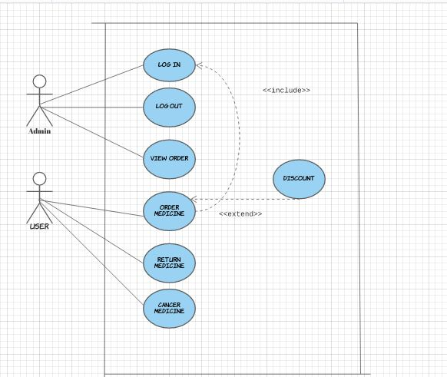

UML Use Case diagram 2:

Online Medicine Service

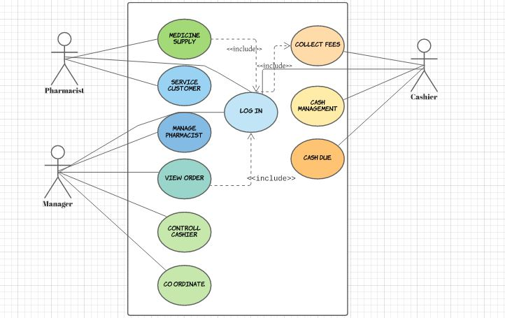

UML Class Diagram:

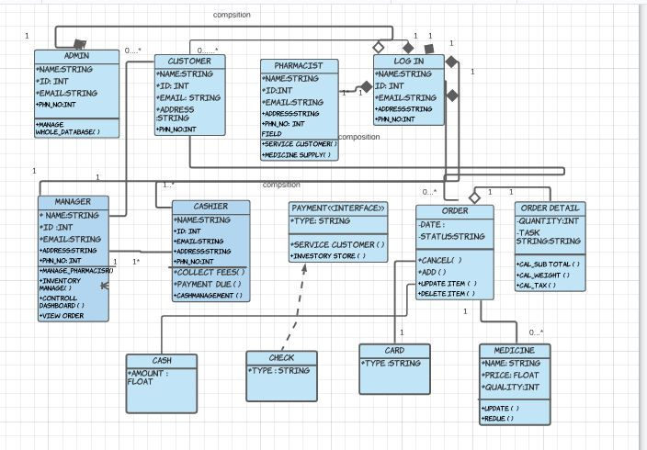

Activity Diagram:

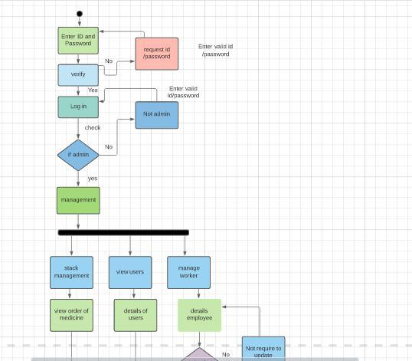

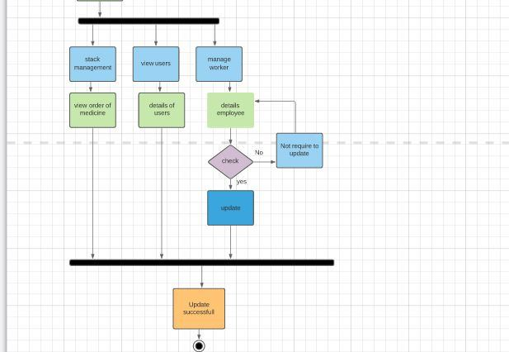

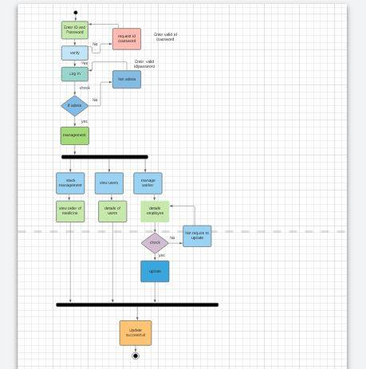

Sequence Diagram:

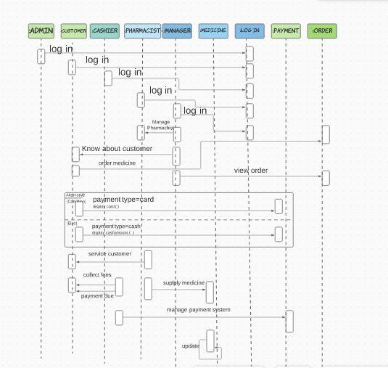

Screenshot:

